**Date of Experiment: 13/02/25**

**Date of Submission:13/02/25**

**SVKM’S NMIMS**

**Mukesh Patel School of Technology Management & Engineering**

Department of Mechatronics Engineering

Subject- Robotic Process Automation

**EXPERIMENT NO. 4**

**Objective:**

The aim of this experiment is to cultivate expertise in Excel automation through Power Automate Desktop, focusing on efficient data manipulation and task automation.

**Prerequisites:**

1. Power Automate Desktop installed on your computer.

2. Basic understanding of Power Automate Desktop interface.

**Challenge Overview:**

In this experiment, you will create 2 flows

1. Develop a Power Automate Desktop flow to identify Armstrong numbers.

**Important Actions:**

1. **Read Cell:**
   * Purpose: Extract data from specific cells in an Excel sheet.
   * Usage: Retrieve test cases for Armstrong number checking and student information for report card generation.
2. **Calculate:**
   * Purpose: Perform arithmetic operations for evaluating Armstrong numbers and calculating grades.
   * Usage: Utilize mathematical calculations within the flow for precise computations.
3. **Decision:**
   * Purpose: Implement conditional branching based on specified criteria.
   * Usage: Guide the flow to different paths for handling Armstrong number identification and grade assignment.
4. **Set Variable:**
   * Purpose: Assign values to variables for storage and manipulation.
   * Usage: Store interim results or information extracted from the Excel sheet for subsequent actions.
5. **Loop (e.g., For Each, While):**
   * Purpose: Repeat a set of actions for each item in a collection or until a condition is met.
   * Usage: Iterate through test cases and student records for efficient processing.
6. **Write Cell:**
   * Purpose: Input data into specific cells in an Excel sheet.
   * Usage: Update the Excel sheet with results, such as Armstrong number identification and generated report card details.
7. **Message Box:**
   * Purpose: Display messages, alerts, or results during the flow execution.
   * Usage: Communicate information to the user or provide feedback on the progress of the flow.
8. **Open Workbook:**
   * Purpose: Open a specified Excel workbook.
   * Usage: Establish a connection with the Excel file to read and write data as needed.
9. **Log Message:**
   * Purpose: Record messages in the log for debugging and troubleshooting.
   * Usage: Assist in diagnosing issues and understanding the flow's behavior, especially during testing and development.

**Tasks:**

1. Create a Power Automate Desktop flow that incorporates the described actions.

2. Test the flow by providing different sets of marks to ensure accurate calculation and grade assignment.

3. Debug and troubleshoot any errors that may arise during the execution of the flow.

4. Optimize the flow for efficiency, considering factors such as readability and simplicity.

**Flow Screenshots:**

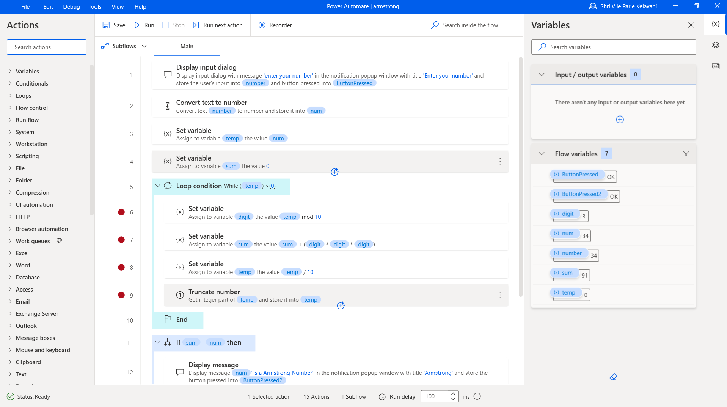

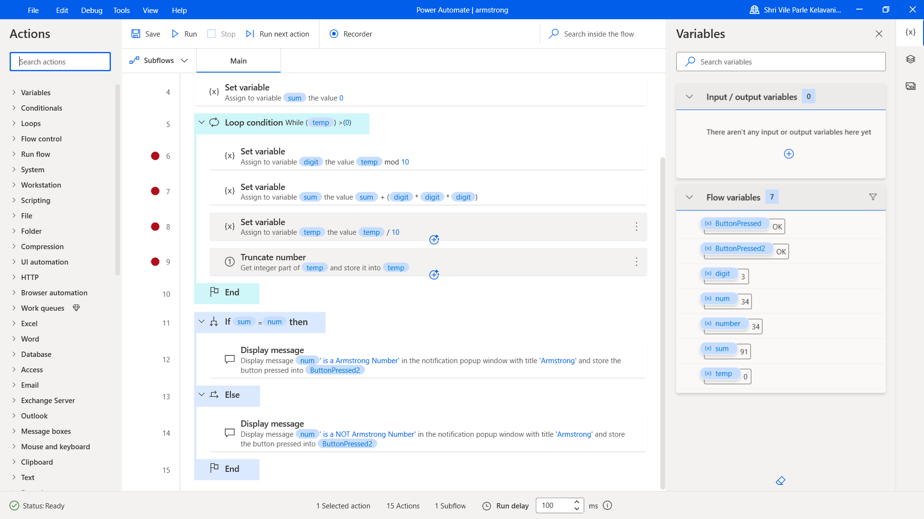

**Input Screenshots:**

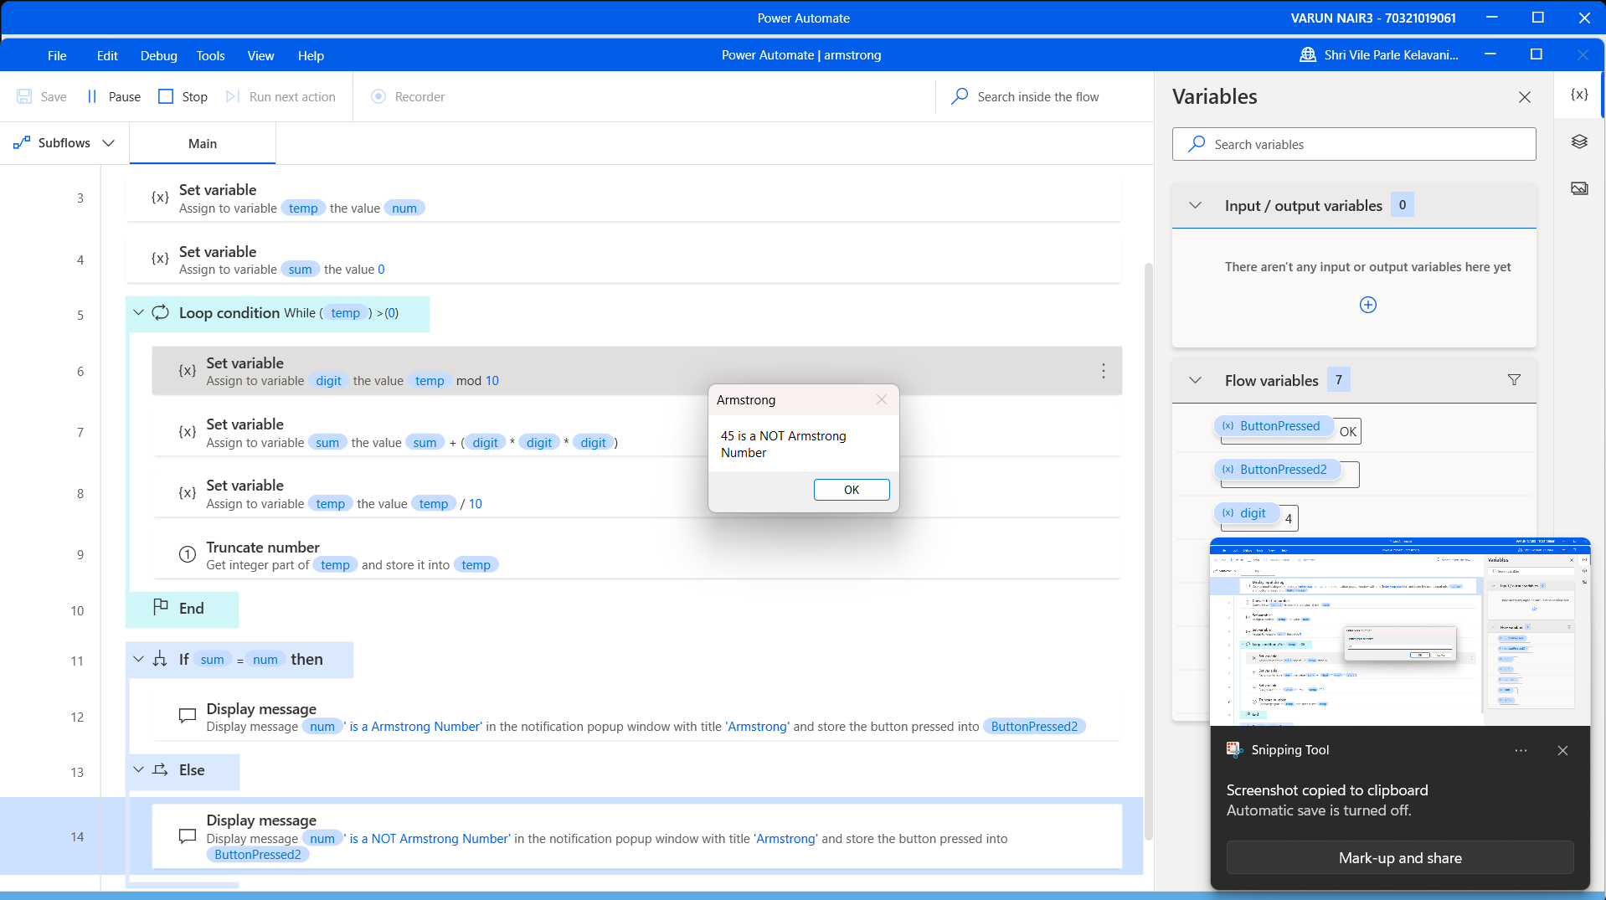

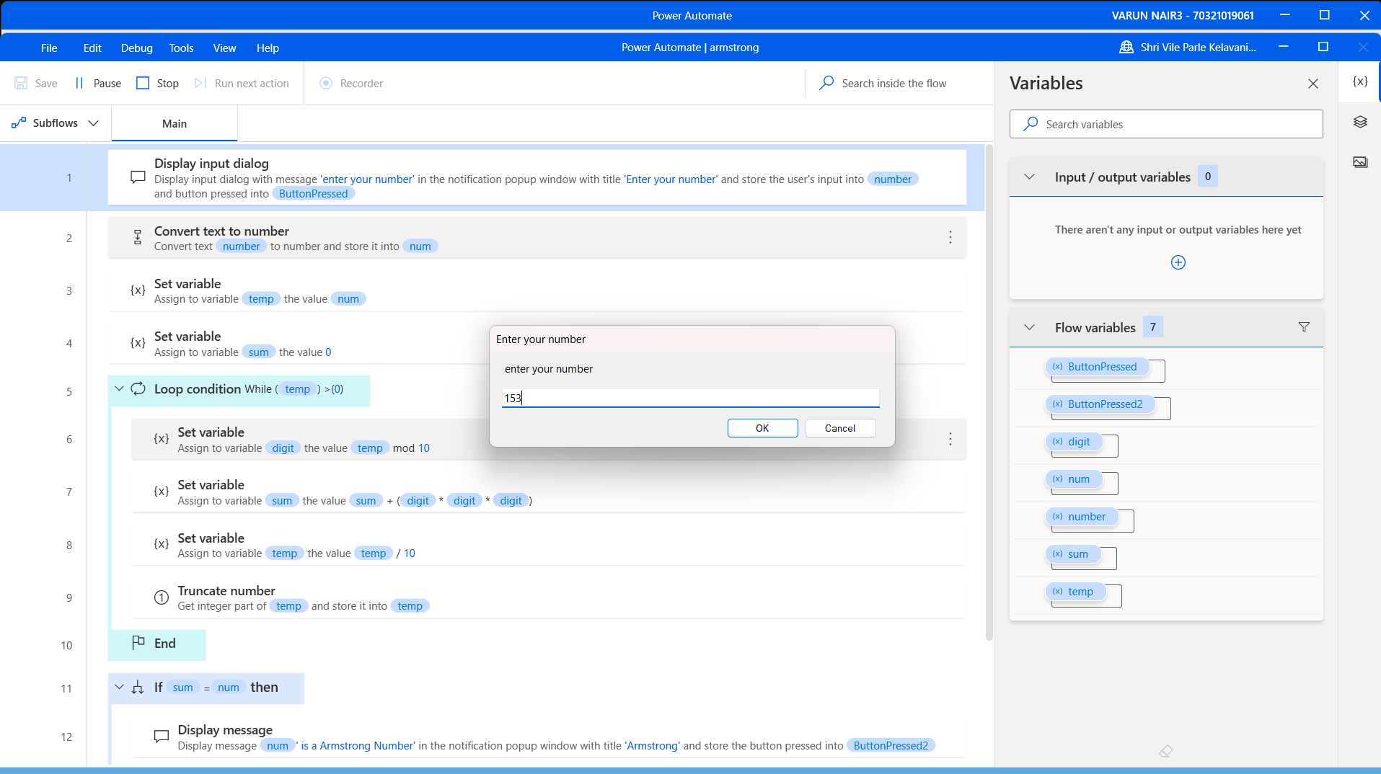

**Output Screenshot:**



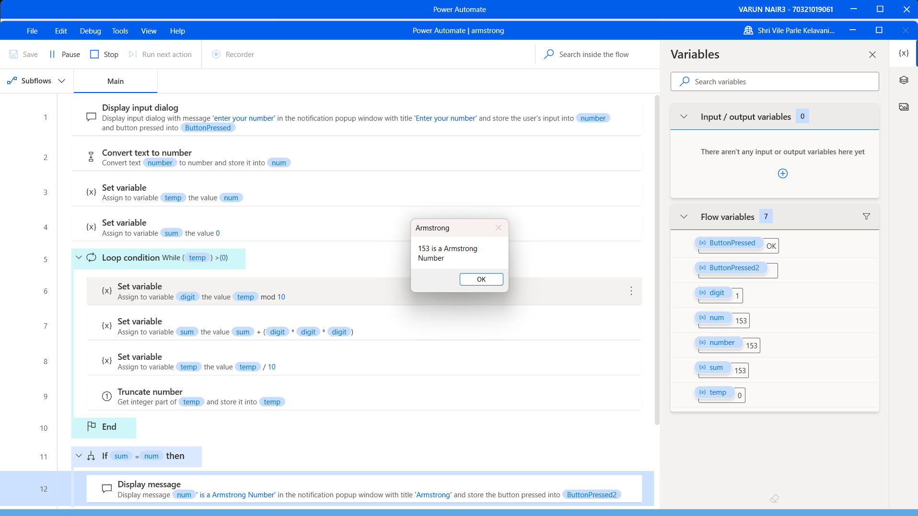

**Conclusion:**

This approach involves converting the input number into a string and iterating through each digit in the string. For each digit, we raise it to the power of the number of digits in the input number, and sum up the results. If the final sum equals the input number, it is an Armstrong number.

Algorithm🡪

1. Convert the input number into a string using str(num).

2. Find the length of the string using len(num_str) and store it in n.

3. Initialize a variable sum to zero.

4. Iterate through each digit in the string using a for loop, and convert each digit back to an integer using int(digit).

5. Raise each digit to the power of n using int(digit)**n, and add the result to sum.

6. After the loop is complete, check whether sum is equal to num.

7. If sum is equal to num, return True (the input number is an Armstrong number).

8. If sum is not equal to num, return False (the input number is not an Armstrong number).

And learnt how to implement a bot to check whether a given number is an Armstrongs number or not.